
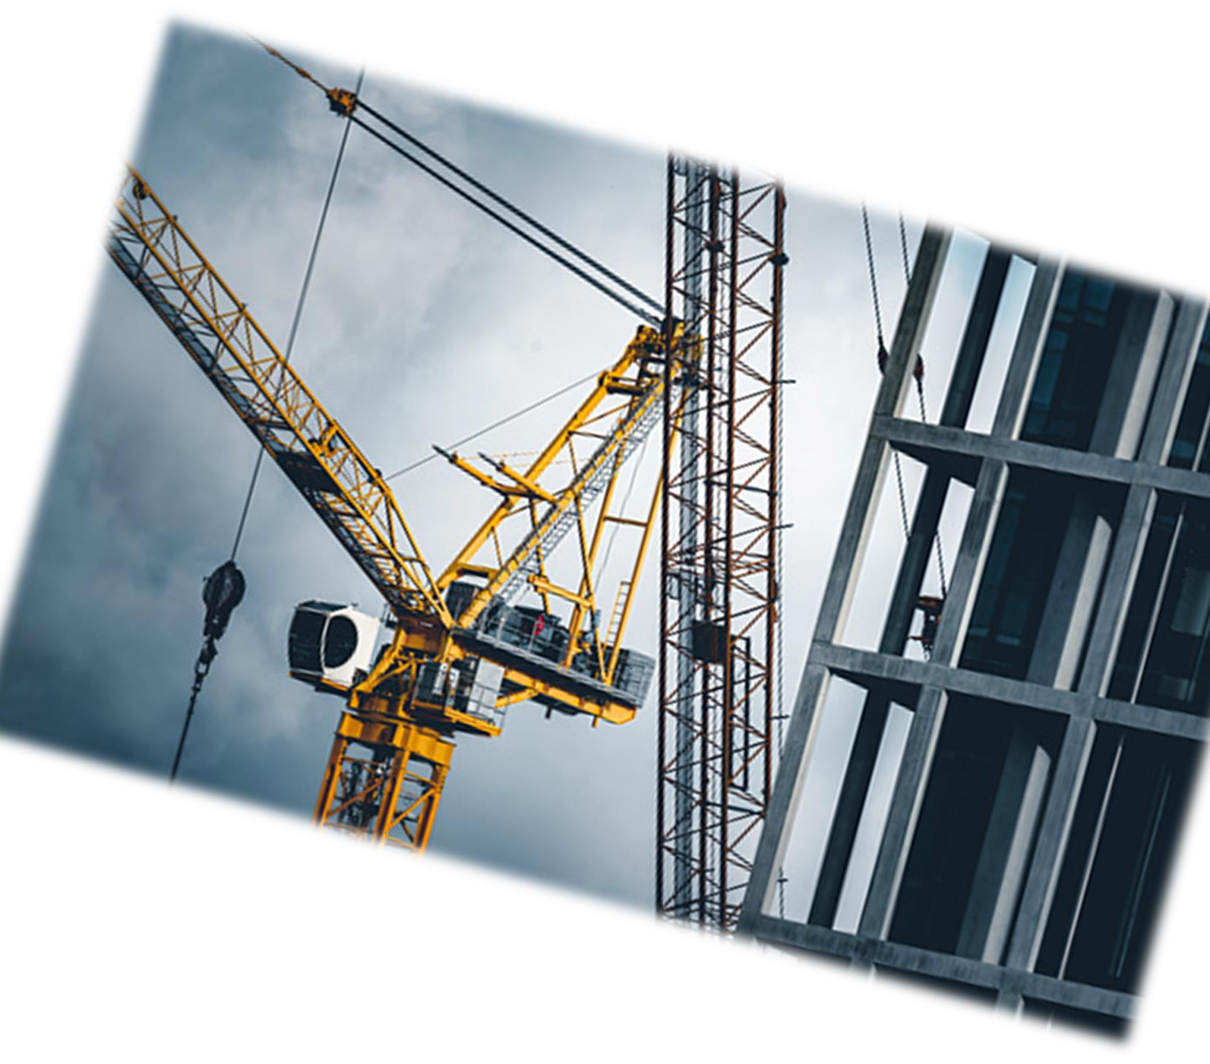
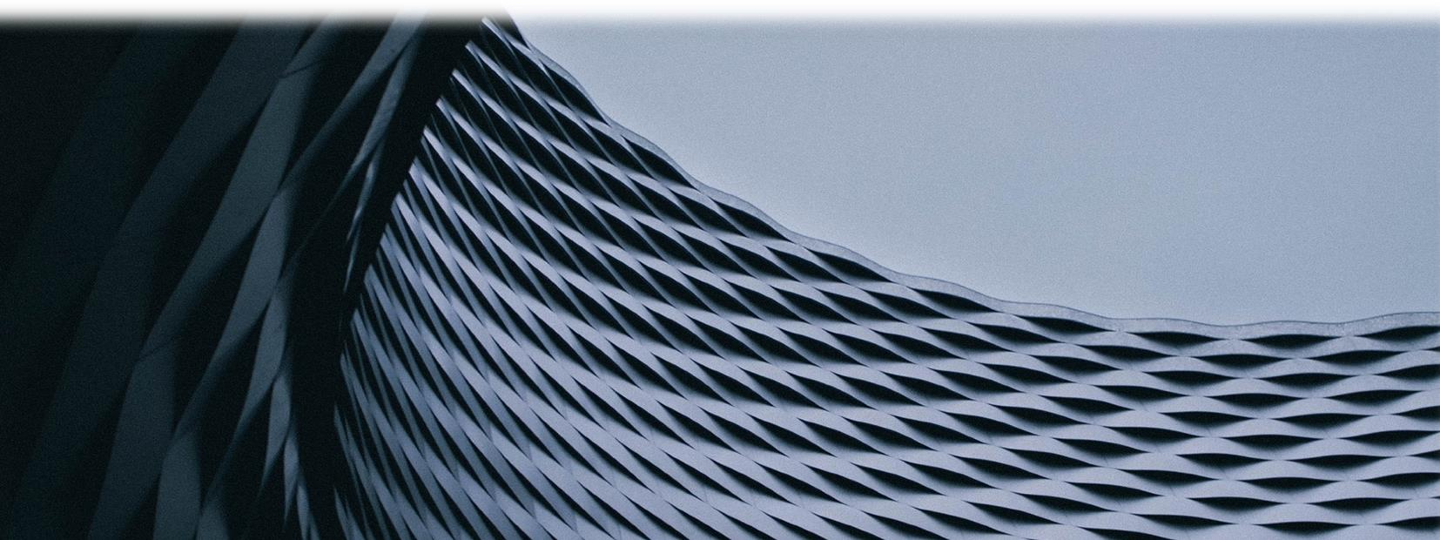


it all starts with,

THE ENDMOST CONCRETE PRODUCT SOLUTION

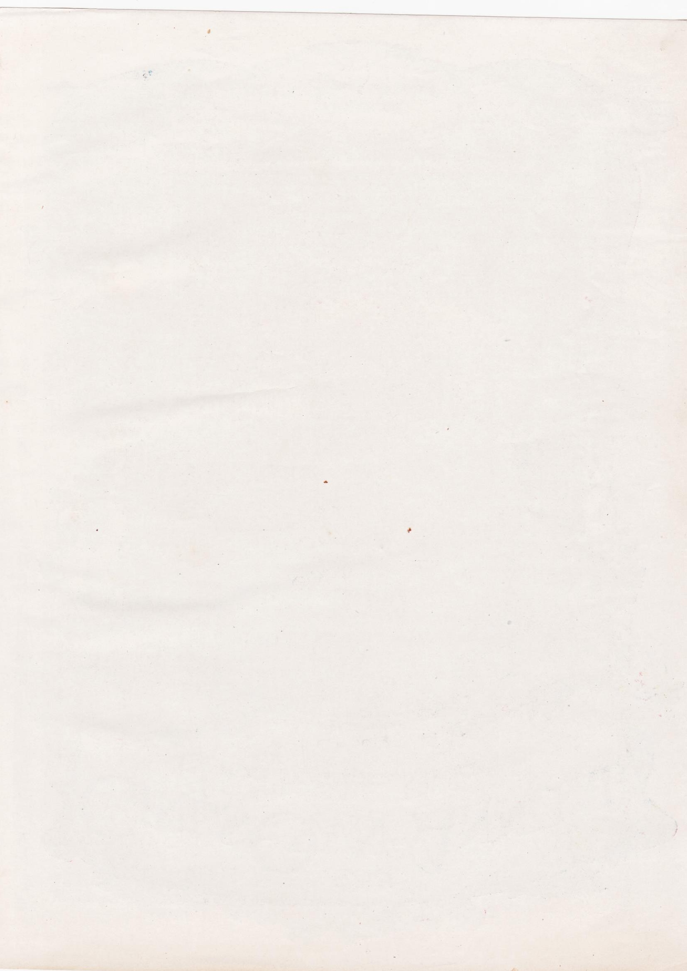



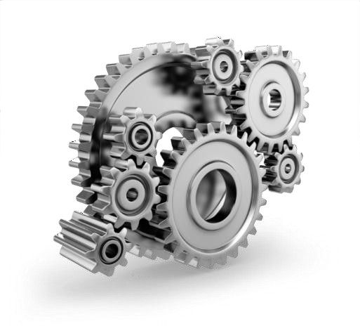


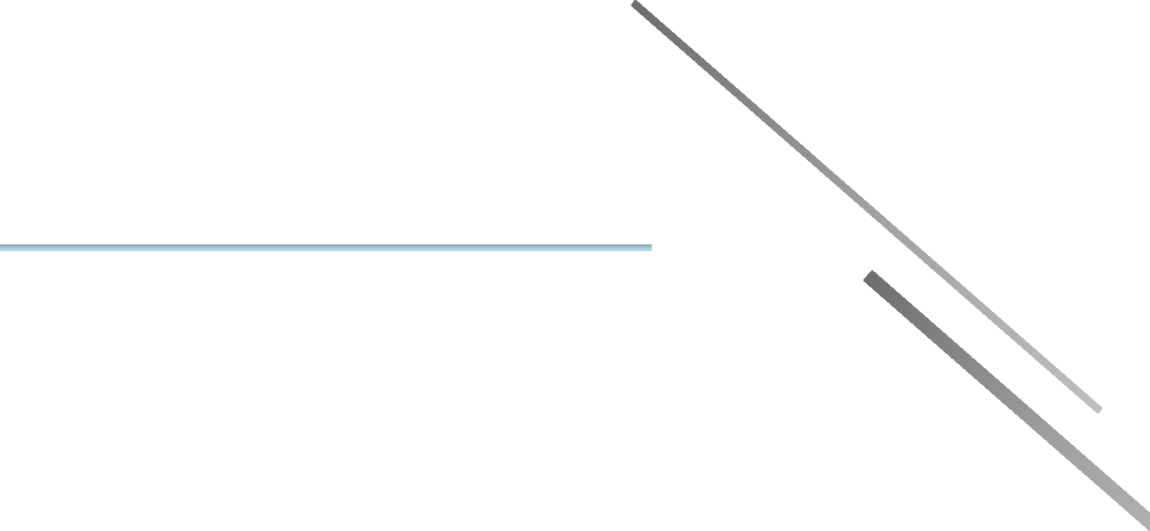
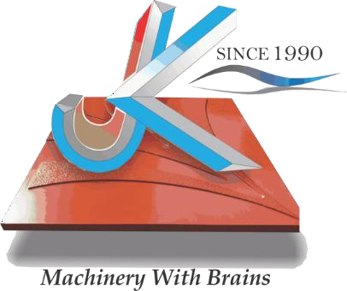
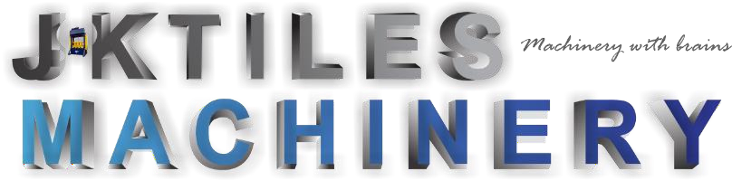

India’s Largest Chain of Machinery Manufacturing for making All types of Pavement Tiles, brick, CC Blocks in secondary industry Sector of manufacturing, Our national presence in 6 Major Indian Cities and 5 Major States -
- Bangalore, Karnataka.
- Hyderabad, Telangana
- Bhubaneshwar, Odisha
- Noida, Uttar Pradesh
- Delhi NCR
- Guwahati, Assam.

P r o s p e c t u s O v e r v i e w

∇ Innovating Automation’s
∇ Endmost Concrete Product Solution
∇ Enthusiasm Customer Priority
∇ Incomparable product.

+91 9618440701
+91

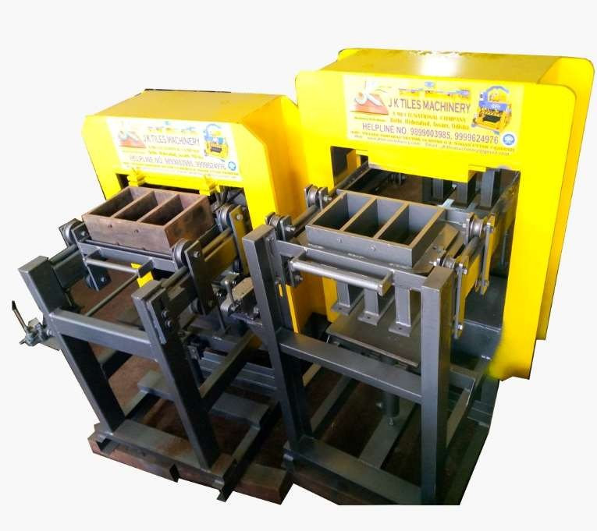


JKTM BSAT 1400 2+3 SEMI AUTOMATIC BRICK & PAVER BLOCK MAKING MACHINE.

Our Esteemed partner


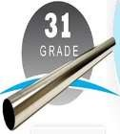



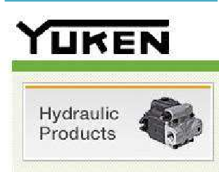
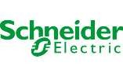

S.NO | FEATURE | SPECIFICATION
1. | TOTAL POWER | (10 HP ) ( 7 KW) ( 14 KVA )  5 HP POWER PACK 5 CONCRETE PAN MIXER
2. | CONTROL PANELS | ALL BRANDED ELECTRICAL ITEMS MULTI FUCTION
3. | MOTORS | CROMPTON / HEVELLS / JKTM / SHREE JEE
4. | WEIGHT | 3280 KG APPROX
5. | HYDRAYLIC | 3 CYLENDERS HEAVY DUTY
6. | PRODUCTION CAPACITY | 5000 TO 6000 IN 8 HOURS
7. | OIL TANK CAPACITY | 350 L.T.R
8. | PRESSURE TONNAGE CAPACITY | 80 TO 100 TONNAGE
9. | MOLDS | 31 GRADE IRON DIE 3 CAVITY BRICKS & 2CAVITY BLOCK
10. | VIBRATING MOTOR | NIL









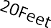
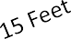

15 Feet

ConcreteBaseDimension ( LXBXH):-












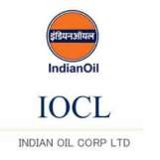

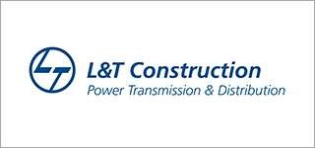

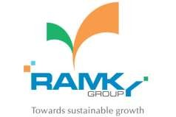

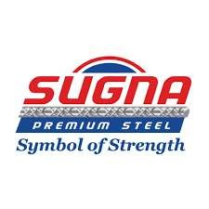
Quotation
Date
20/03/2024

HYDRAULIC
Plant Type:

Salesperson :
MR. Iqbal Khan
Payment
Terms:
N/a
JKNID1450
Company Add:
Sy No. 102/4,Vill-Sulikunte , Sarjapur Main Road, Near Shell Petrol Pump,
Varthur Hobli, Bengaluru, Karnataka 560035. GSTIN :29AATFJ8939N1Z1
E mail : Jktilesmachinery5@gmail.com, jktilesmachinery1@gmail.com jktilesmachinery3@gmail.com
jktilesmachinery2@gmail.com,
Website : www.Jktilesmachinery.com, www.jktilesmachinery.co.in, www.jktilesmachinery.co.in, www.jktilesmachinery.in ,jktilesmachinery.co
Mob :+91 9618440701
+91 9880513018
+91 9656860786
Invoice And Shipping Address :
M/S Newtech precast products
GSTIN:- 33DLRPS3467Q3ZX
4/911-5A, Pattakurubarapalli, Karubala Bus Stand, Shoolagiri, Chembarasanapalli, Krishnagiri, Tamil Nadu, 635117

M A C H I N E R Y
Quotation # 100011

1. | 2+3 CAVITY BRICK & BLOCK MAKING MACHINE (MODEL JKTM SMATG541)  3 CYLENDERS HEAVY DUTY | 1.UNIT
2. | BRICK MOULD SET SIZE (9"x4"x3")  : 3+3 Cavity Punch  : 31 grade iron  : High Density Tempered | 1 Pcs
3. | POWER PACK  Crompton / Hevells / Jktm / Shree Jee | 1 Pcs
 | PLC PANEL  All Branded Electrical Items Multi Fuction | 1 Pcs
 | CONCRETE PAN MIXER 350KG CAPACITY  Motor : HP(Crompton/ Havells)  Gear Box : 11 Liters  System :Roller / Blade  Capacity : 350kg | (Optional)
 |  |  | Total | 6,49,000/-
 |  |  | Discount | 42000/-
Note :  - Above Pricing Is Excluding GST 18 %, that will be extra.  - TRANSPORTION WILL BE EXTRA  - Pan mixer 350 kg is not included in this pricing customer need to buy the same separately |  |  | G TOTAL  (After  Discount) | 6,07,000/-


- Prices are Ex-Works Noida, Uttar Pradesh.

- Delivery time – 30-40 Days from the date of Advance Payment.

- 40% Payment As Advance at the time of placing order

- 60% Remaining payment at the time of delivery or before dispatch.(Then Only tax invoice will be generated)

- Any Amendments or Items Decrement in this quotation will lead to Regeneration of quotation.

- The Machinery Carries One (01) Year on Site warranty from the Date of Dispatch.

- Warranty on the Induction motors will be void if Proper Electrical fittings are not done as per our specification. (fittings like proper Motor Starter along with Phase Preventers)
- All Transportation Extra To be borne by Client

- Quotation will be Revised or Amended if Any item in the quotation is Removed or added(in that case, discount will also be revised).
- Hydraulic Oil is not included with the machine, have to buy separately from the machine.

- Production of the machine varies on the practical field as compared to theoretical calculations written on the specification file.


Bank Name : HDFC Bank LTD.
Account Name : J K TILES MACHINERY
Account No : 50200092115339
Registered Mob No : 7272830786
IFSC Code : HDFC0004843





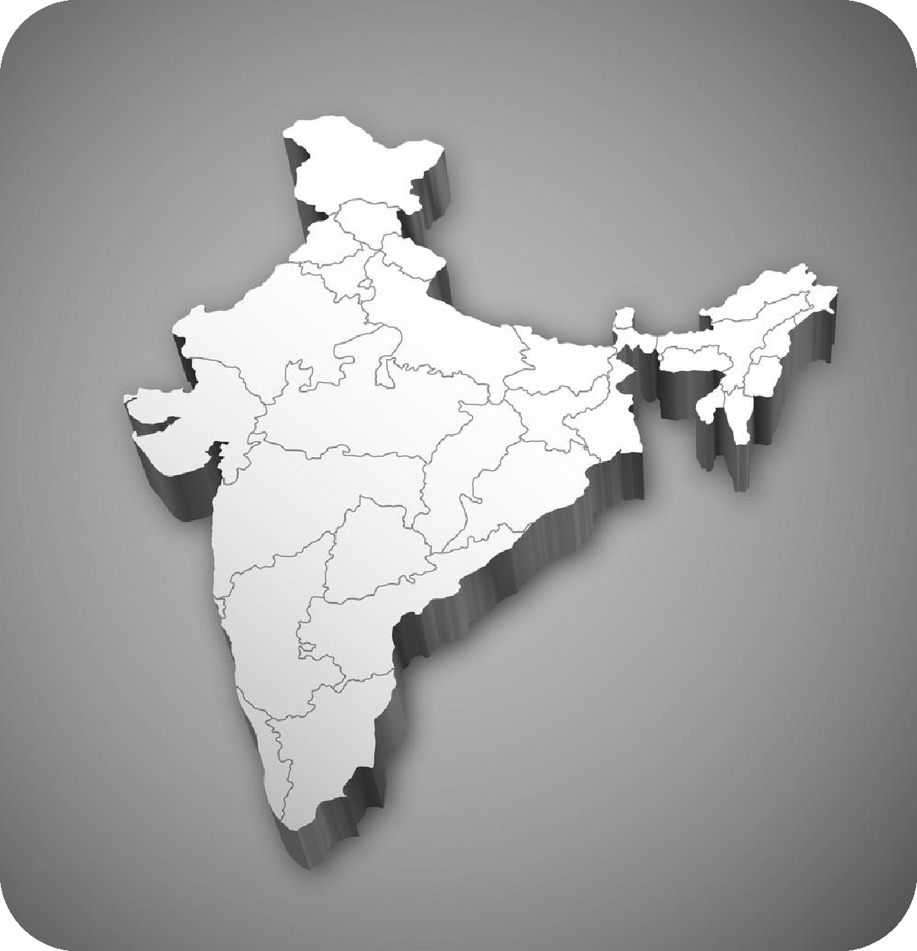

Our National Presence
in Five Major States.

ASSAM, GUWAHATI

Noida NCR ( HEAD OFFICE )

Bhubaneshwar (ODISHA)

HYDERABAD, TELANGANA

BANGALORE, KARNATAKA



We Hope You Find Our Above Prospectus To Your Whole Satisfaction By All Terms, We Request You To Kindly Place Your Valuable Orders, Which Receive Our Best Attention And Promote Execution. Hope That We Can Establish
A Good Business Relationship In The Nearest Future. Thanks.


Mob :+91 9618440701 Email :Jktilesmachinery5@gmail.com web :- www.jktilesmachinery.org
+91 9880513018 Jktilesmachinery@gmail.com www.jktilesmachinery.in
Jktilesmachinery3@gmail.com

+91 9880513018



